Lab Exercise - Create IAM User in Azure using Cloud Shell

Objective
Create an IAM user in Azure using Azure Cloud Shell and assign RBAC permissions.

Prerequisites
- Azure Subscription
- Azure Cloud Shell access
- Permission to create users in Microsoft Entra ID

Lab Architecture
Microsoft Entra ID
↓
Create IAM User
↓
Assign RBAC Role
↓
Verify User Access

Step 1 — Open Azure Cloud Shell
Open:
Azure Portal
Open:
- Cloud Shell
- Select Bash

Step 2 — Check Current Azure Account
Run:
az account show --output table

az rest --method get \
--url https://graph.microsoft.com/v1.0/domains

This shows:
- Subscription
- Tenant
- Logged-in account

Step 3 — Set Variables
USERNAME=testuser
DOMAIN=<yourdomain>
PASSWORD='Azure@123456'

Example:
USERNAME=testuser
DOMAIN=contoso.onmicrosoft.com
PASSWORD='Azure@123456'

Step 4 — Create IAM User
Run:
az ad user create \
--display-name $USERNAME \
--user-principal-name $USERNAME@$DOMAIN \
--password $PASSWORD

Example Output:
{
“displayName”: “testuser”,
“userPrincipalName”: “testuser@contoso.onmicrosoft.com”,
“accountEnabled”: true
}

Step 5 — Verify User Creation
Run:
az ad user list \
--output table

You should see:
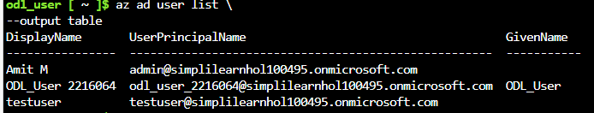

Step 6 — Get Subscription ID
Run:
az account show –query id –output tsv

Copy the subscription ID.
Example:
12345678-1234-1234-1234-123456789012

Step 9 — Reset User Password (Optional)
PASSWORD='Demo@123456'

az ad user update \
--id $USERNAME@$DOMAIN \
--password $PASSWORD

Step 10 — Delete IAM User (Cleanup)
az ad user delete \
--id $USERNAME@$DOMAIN

Important Azure IAM Concepts
Concept | Description
Authentication | Verifying user identity
Authorization | Granting permissions
RBAC | Role-Based Access Control
Least Privilege | Minimum required access

